

ArcelorMittal Building Solutions France Procedure 1.1.1.5

Balance creation

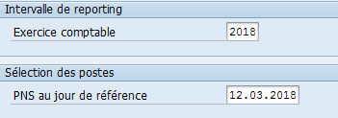
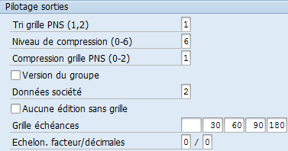
In SAP, select transaction S_ALR_87012178 :
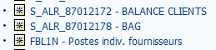
The name may differ, but not the transaction code

- Access a variant / delete name in "created by" / F8

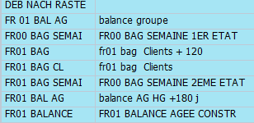
- Select the desired variant:

/FR01 BAL AG - balance AG HG + 180j OUTSIDE GROUP
/FR01 BAL AG - group balance GROUP

Complete :
- Financial year: current year
- PNS on key date: current date or end of the month
- For the group variant, in the last tab, due date grid, replace "120" with "180".

Execute (F8)

List / Save-Send / File / Spreadsheet calculation

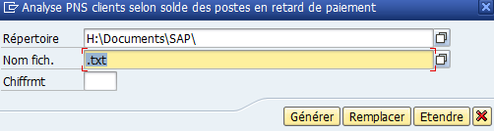
Excel format (xlsx)

Generate

2. EXCEL

Open file :

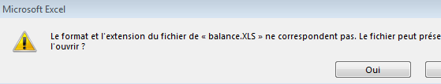

Task:
- Delete the first 5 rows
- Delete all rows where the country is not entered in the 5th column (tip: F4 to repeat the last action)
- Delete empty columns
- Select columns with numbers / CTRL+F / replace ". "with nothing
- Add a last column for the total with the formula "Total PNS - From 0".
- Sort this last column by amount, descending order

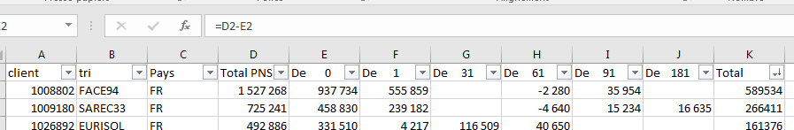

Save in :
K:/ Customer credit / Balance / BAL 20xx / ...

Balance to be taken out regularly:
- End of month
- 15th of the month
- For dunning
- Closed
- At CreditManager's request

On: 03/11/2025
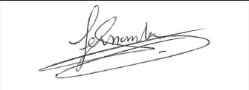
Procedure validated by : S. HERNANDEZ

